Test Waf Block/ C4

Technical Design Documentation

Contents

1. Instruction 2

2. Explanation 2

# Instruction

This application is for testing Waf is blocked or not.

In folder file -> tempFile.txt, this is the input case for the test. You can add a new case in a new line. We already have some cases in this file.

In file .env -> URI = <https://www.example.com/> is the website which need to be test.

After modifying tempFile.txt and .env, start testing by double click application validCheck.exe. The application will execute and the result.txt will be created.

# Explanation

After the application finish, the result will be saved in the result.txt file.

This application will test 4 cases for each input test include:

* The input in the URI. (1)
* The input in the Param. (2)
* The input in the Reference. (3)
* The input in the User-Agent. (4)

If you see a result in a single case like this picture below. It means WAF blocked this input case.

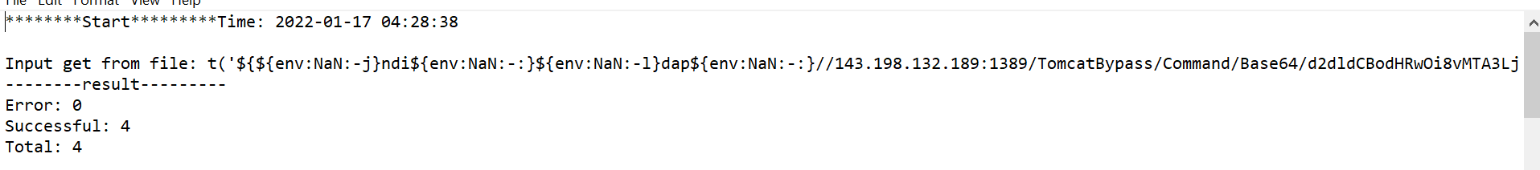

If result error like this picture below, it means WAF not block in this case, base on the specific case in 4 cases, error logs will be show. For example in the case only uri (1), the status code must be 403 but we received 404, also case param (2), ref (3), userAgent(4) status code must be 403.

We have conclusion total case test in Total field, not blocked by WAF in Error field and blocked in Successful field.

